MOVIE CATALOG API
PROJECT DOCUMENTATION

1. Introduction
This project is a RESTful API developed using ASP.NET Core for managing movies and directors. It allows users to perform CRUD operations and follows REST principles.

2. Objectives
- Implement CRUD operations
- Follow RESTful architecture
- Test API using Postman
- Debug API using Fiddler
- Implement relationships between entities

3. Technology Stack
- ASP.NET Core Web API
- Entity Framework Core
- SQLite Database
- Postman
- Fiddler

4. User Story 1: CRUD Operations
Implemented endpoints for Create, Read, Update, Delete operations.
Endpoints:
GET /api/movies
POST /api/movies
PUT /api/movies/{id}
DELETE /api/movies/{id}

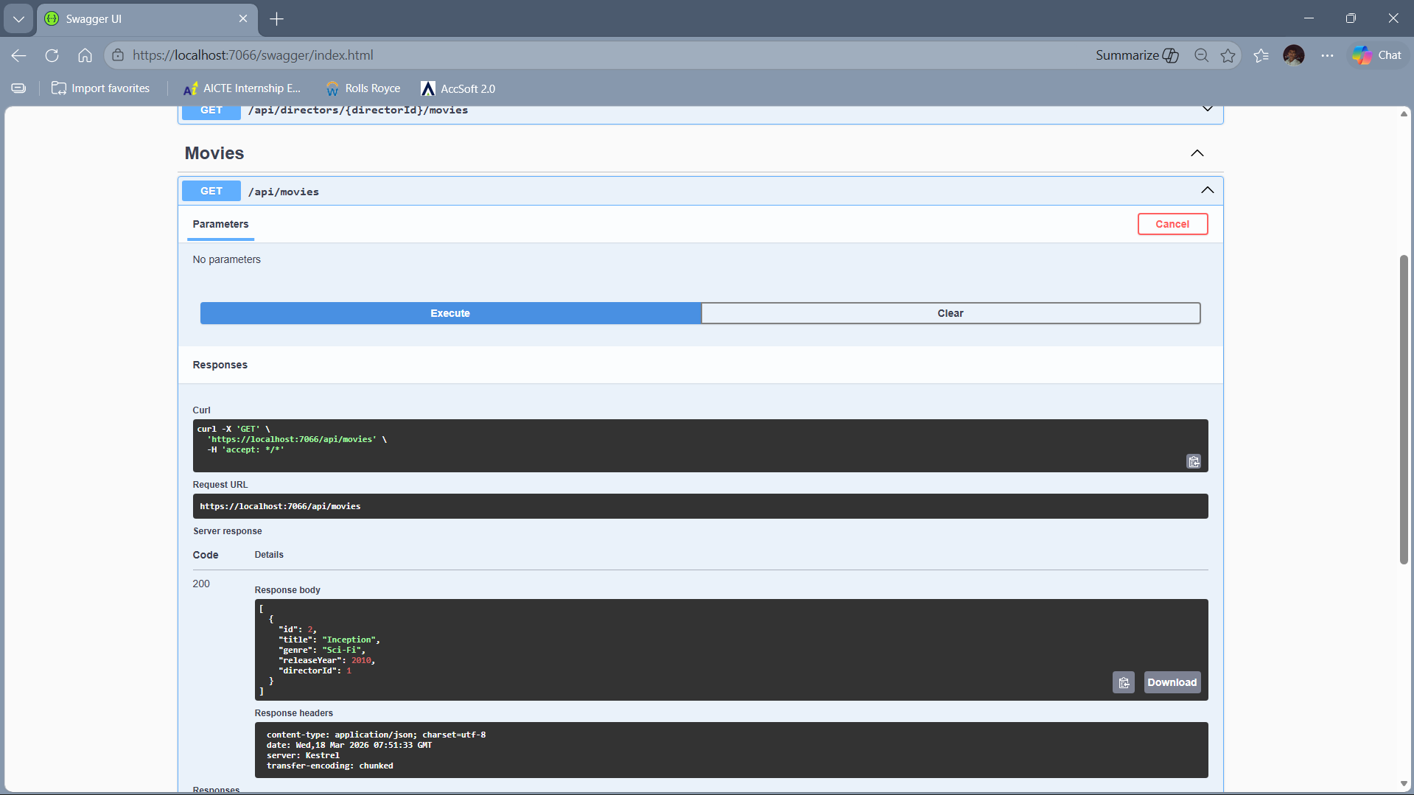
Description: Shows all movies returned with status 200 OK.
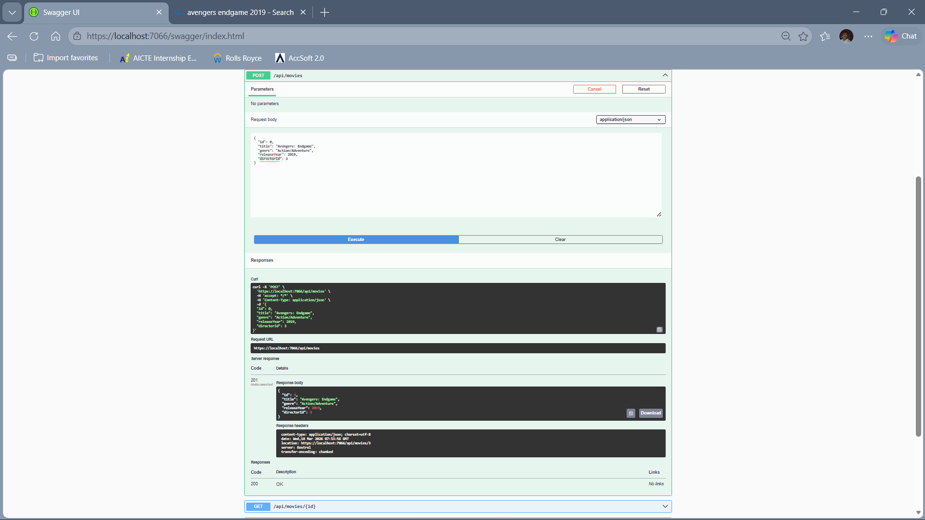
Description: Shows successful creation with status 201 Created.

5. User Story 2: Postman Testing
All API endpoints were tested using Postman. Verified status codes and JSON responses.
Edge cases like invalid ID and missing fields were also tested.
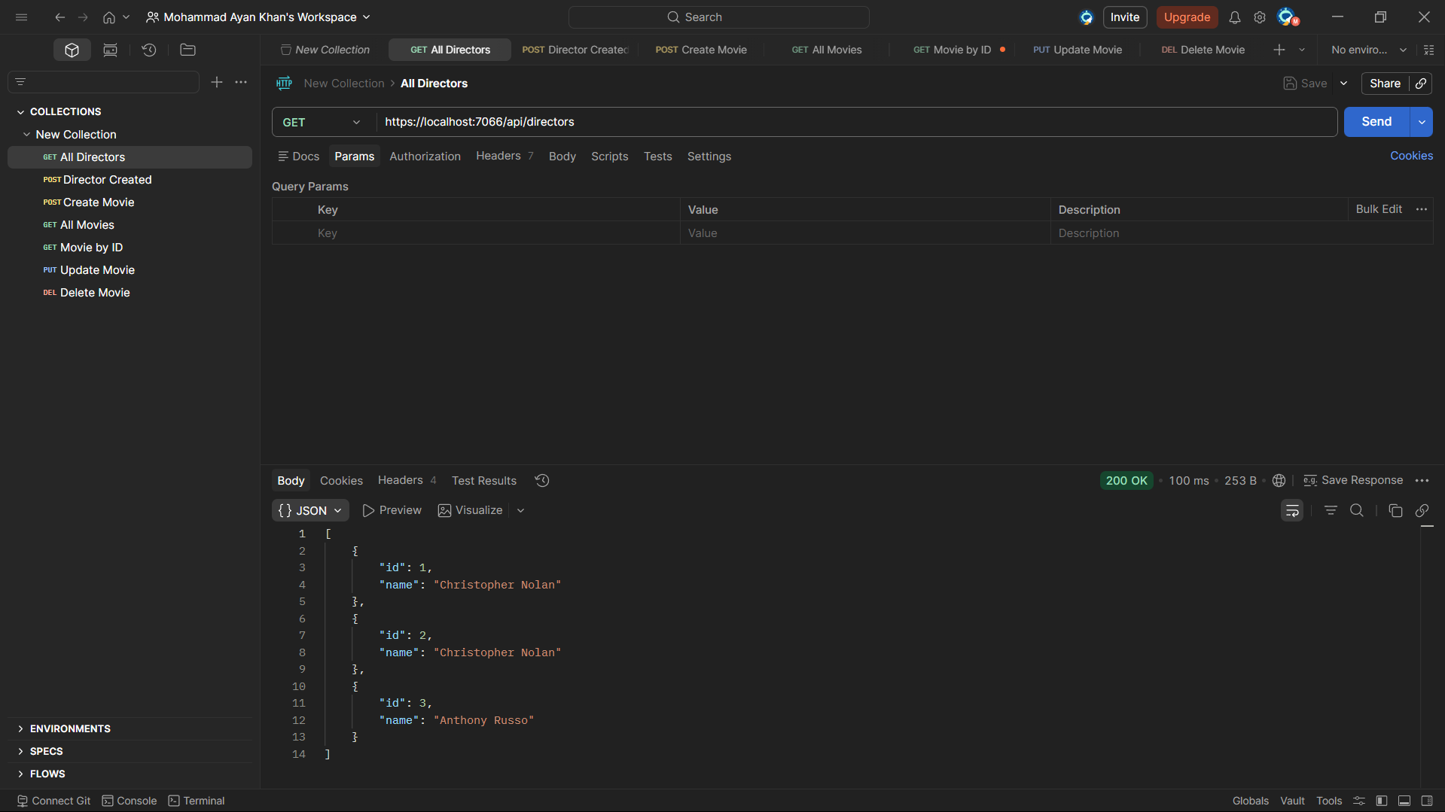
Description: Displays list of directors.
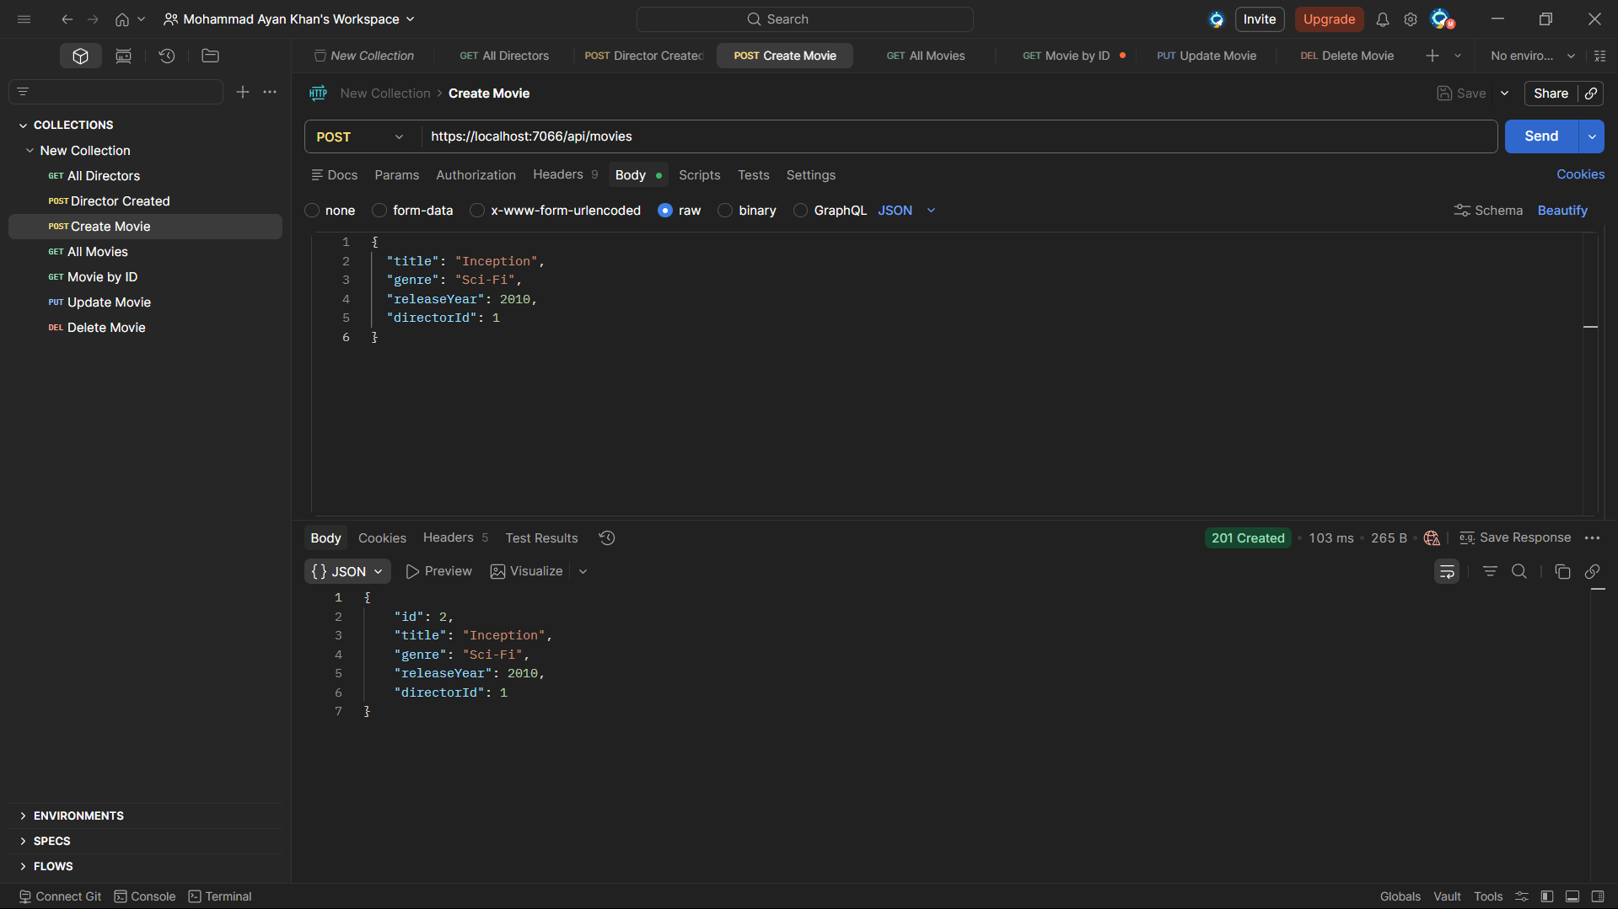
Description: Shows successful movie creation.
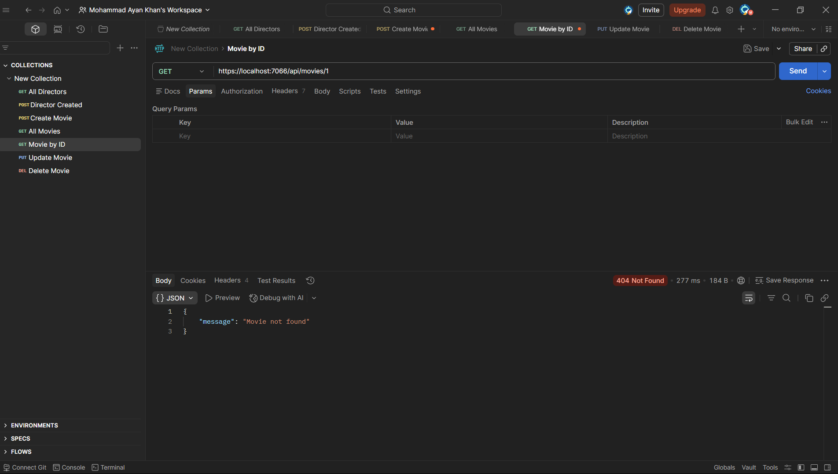
Description: Shows error when resource not found.

6. User Story 3: Fiddler Debugging
Fiddler was used to inspect HTTP requests and responses, including headers and status codes.
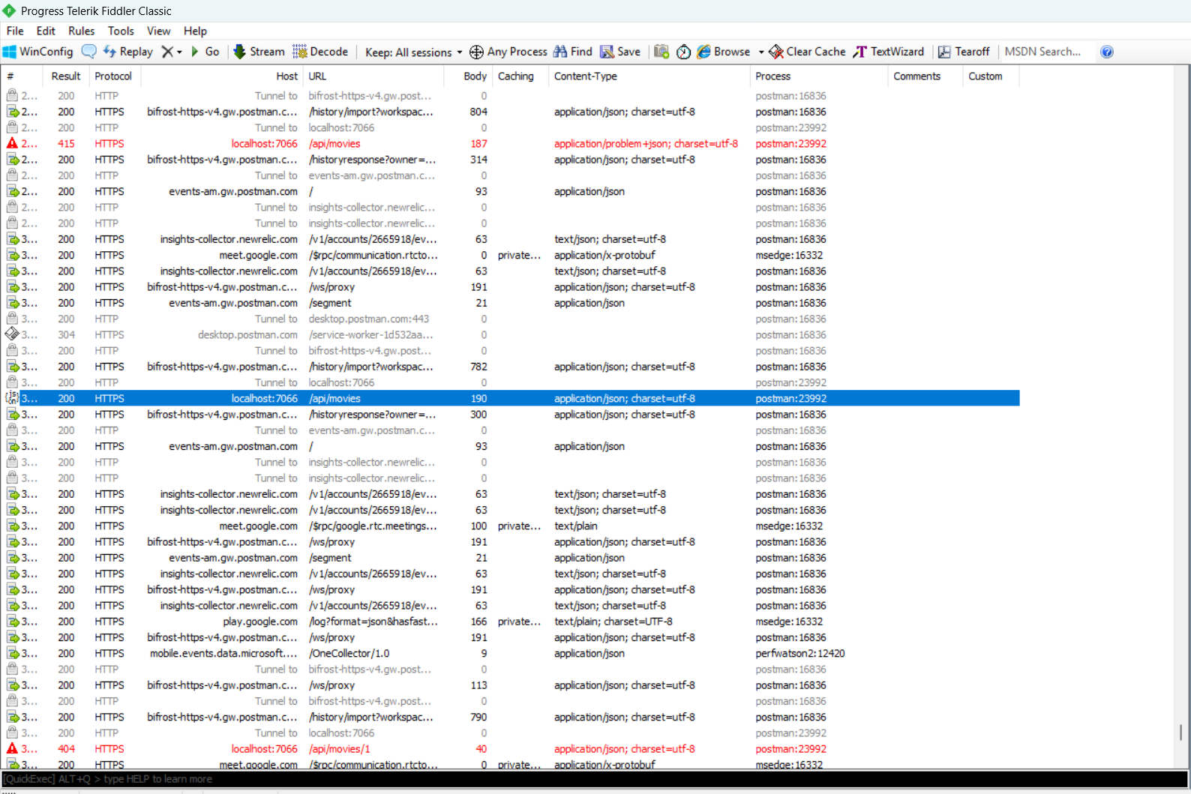
Description: Shows captured API request.
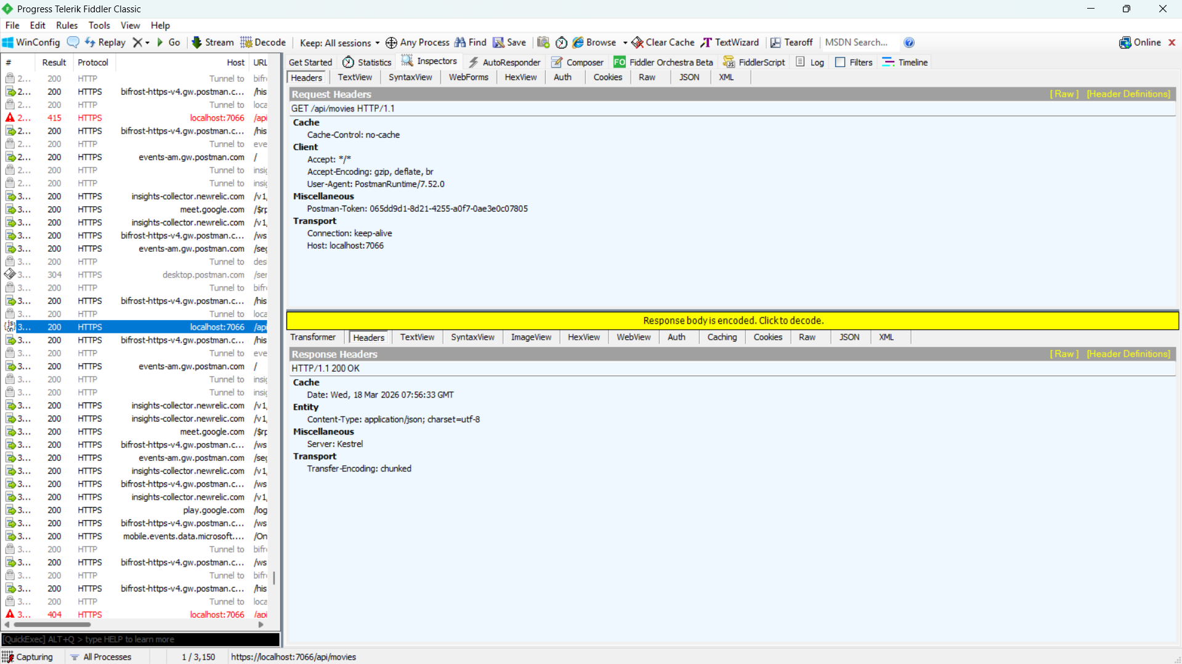
Description: Shows Content-Type as application/json.

7. User Story 4: Associations
Implemented one-to-many relationship between directors and movies.
Endpoint: GET /api/directors/{id}/movies retrieves movies of a specific director.
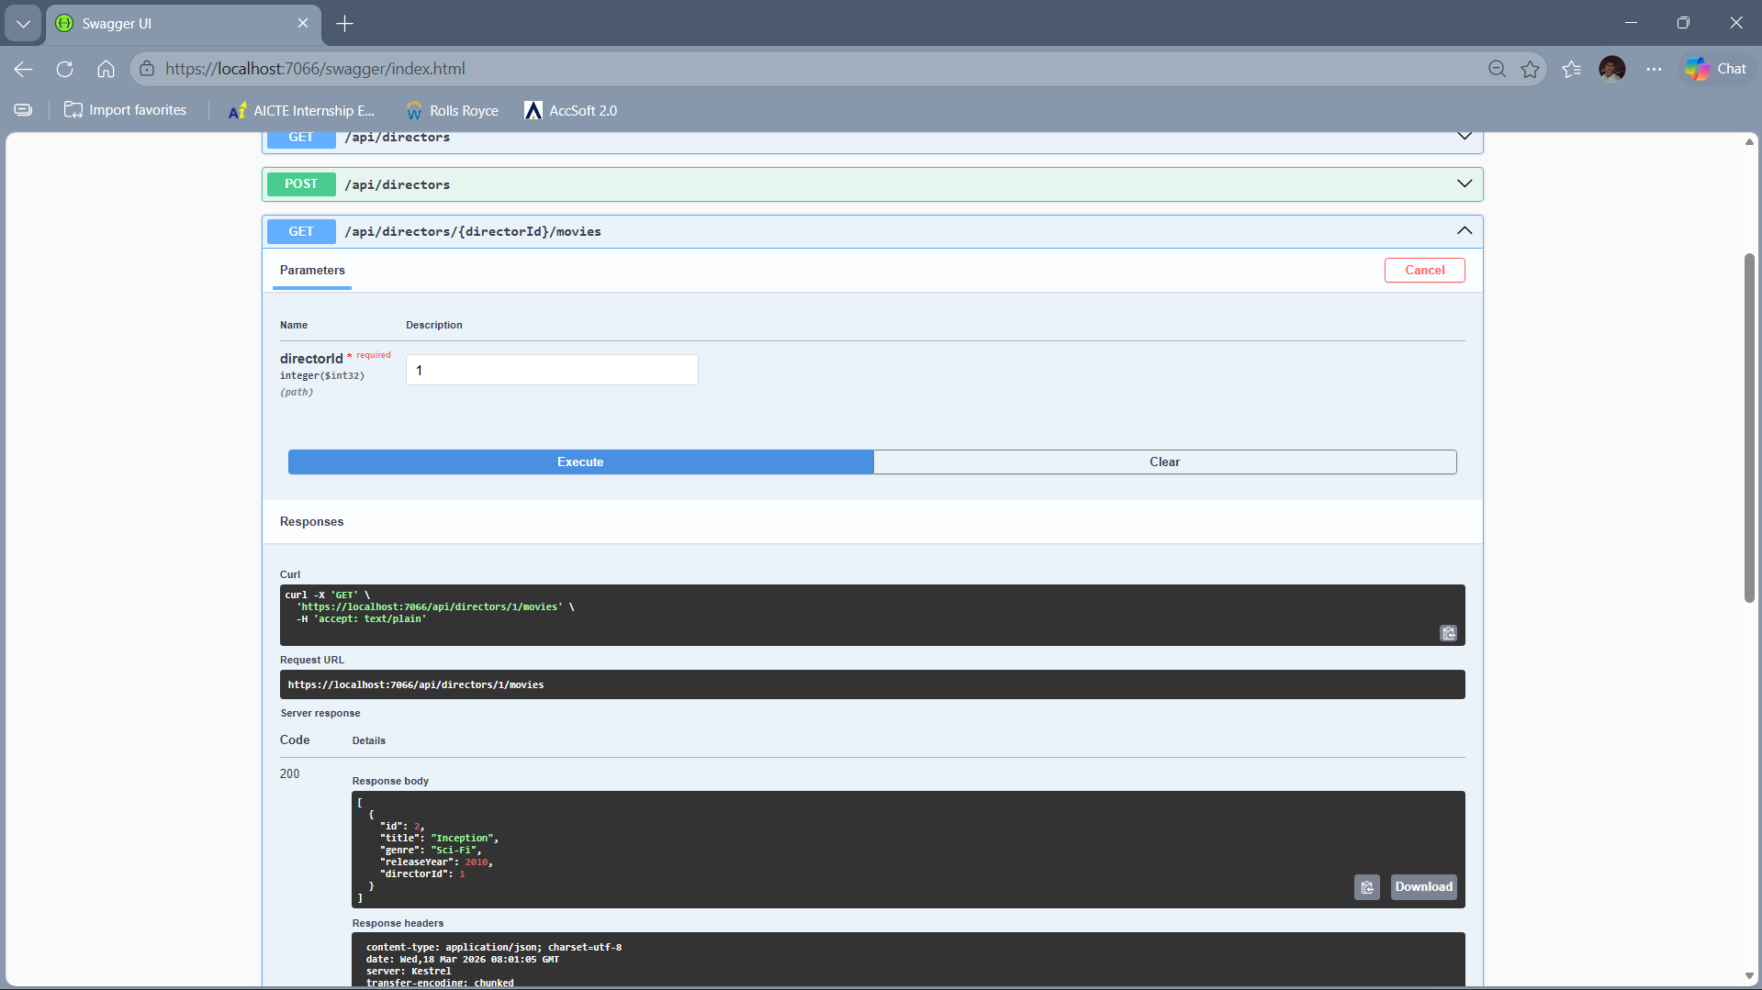
Description: Shows movies fetched by director ID.

8. User Story 5: Attribute Routing
Used attribute routing to define clean and RESTful endpoints such as:
/api/movies/{id}
/api/directors/{id}/movies
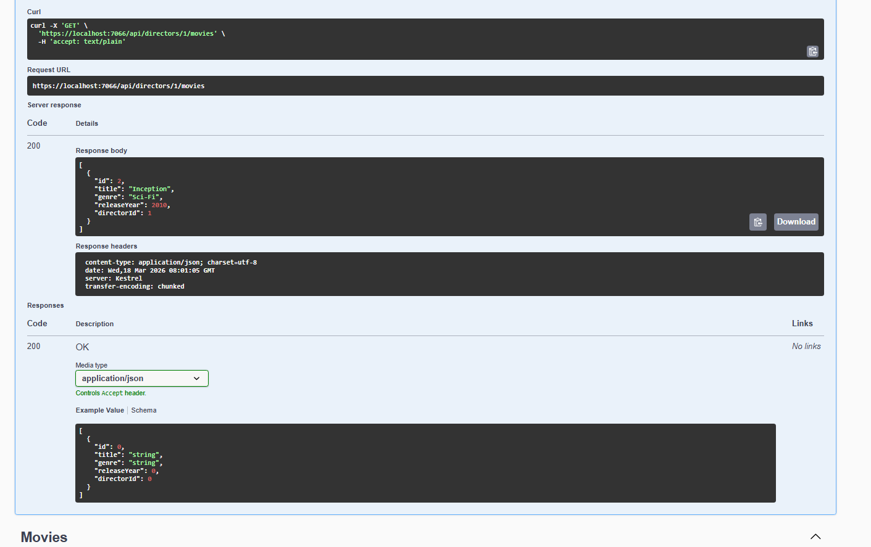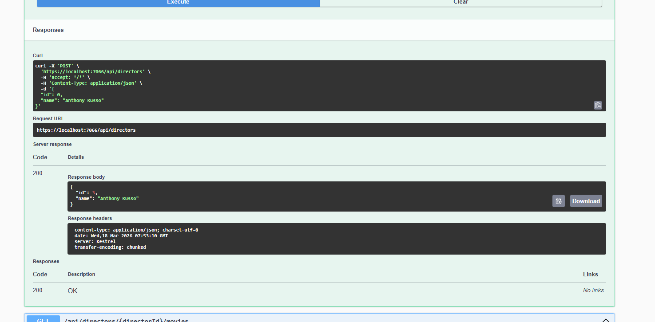
Description: Shows structured API endpoints.

9. Error Handling
Handled errors using appropriate HTTP status codes such as 400, 404, and 500 with meaningful messages.

10. Conclusion
The project successfully demonstrates RESTful API development with proper routing, testing, debugging, and data handling.

